* **Create a class Database with 2 instance variables port and name. Configure Database class bean in spring container through Spring XML. Initialize instance variables using setter method.**

**Spring-config.xml**

*<?***xml version="1.0" encoding="UTF-8"***?>*<**beans xmlns="http://www.springframework.org/schema/beans"  
 xmlns:xsi="http://www.w3.org/2001/XMLSchema-instance"  
 xsi:schemaLocation="http://www.springframework.org/schema/beans http://www.springframework.org/schema/beans/spring-beans.xsd"**>  
  
 <**bean name = "exercise1" class="main.resource.Database"**>  
 <**property name="port" value="3306"**></**property**>  
 <**property name="name" value="Mysql"**/>  
 </**bean**>

</**beans**>

**Database.java**

**package** main.resource;  
**public class** Database {  
 **int port**;  
 String **name**;  
  
 **public int** getPort() {  
 **return port**;  
 }  
  
 **public void** setPort(**int** port) {  
 **this**.**port** = port;  
 }  
  
 **public** String getName() {  
 **return name**;  
 }  
  
 **public void** setName(String name) {  
 **this**.**name** = name;  
 }  
  
 @Override  
 **public** String toString() {**return "Port: "**+getPort()+**"\nName: "**+getName();  
 }  
}

* **Get the bean of the class from spring container and print the values of the instance variable.**

**DatabaseMain.java**

**package** main.resource;  
  
**import** org.springframework.context.ApplicationContext;  
**import** org.springframework.context.support.ClassPathXmlApplicationContext;  
  
**public class** DatabaseMain {  
 **public static void** main(String[] args) {  
 ApplicationContext applicationContext = **new** ClassPathXmlApplicationContext(**"spring-config.xml"**);  
 Database database = (Database) applicationContext.getBean(**"exercise1"**);  
 System.***out***.println(database);  
 }  
}

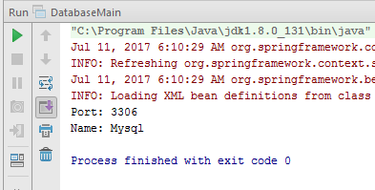

* **Create a class Restaurant. Create an interface HotDrink with an abstract method prepareHotDrink. Create two classes Tea and ExpressTea which implements HotDrink Class. Create an instance variable of type HotDrink in Restaurant class. Configure Tea and ExpressTea classes beans in Spring XML. create a bean with the name teaRestaurant of type Restaurant which inject Tea object as dependency using setter method.**

**Restraunt.java**

**package** main.resource;  
  
**import** org.springframework.beans.factory.annotation.Autowired;  
**import** org.springframework.beans.factory.annotation.Required;  
  
**public class** Restaurant {  
 HotDrink **hotDrink**;  
  
**public** HotDrink getHotDrink() {  
 **return hotDrink**;  
 }  
  
**public void** setHotDrink(HotDrink hotDrink) {  
 **this**.**hotDrink** = hotDrink;  
 }  
  
 @Override  
 **public** String toString() {

**return "HotDrink: "**+**hotDrink**;  
 }  
}

**HotDrink.java**

**package** main.resource;  
**public interface** HotDrink {  
 **public void** prepareHotDrink();  
  
  
}

**Tea.java**

**package** main.resource;  
**public class** Tea **implements** HotDrink{  
 **public void** prepareHotDrink(){  
 System.***out***.println(**"prepareHotDrink IN Tea"**);  
 }  
}

**ExpessTea.java**

**package** main.resource;  
  
**public class** ExpressTea **implements** HotDrink{  
 **public void** prepareHotDrink(){  
 System.***out***.println(**"Prepare hot drink inside ExpressTea"**);  
 }  
  
}

**spring-config.java**

*<?***xml version="1.0" encoding="UTF-8"***?>*<**beans xmlns="http://www.springframework.org/schema/beans"  
 xmlns:xsi="http://www.w3.org/2001/XMLSchema-instance"  
 xsi:schemaLocation="http://www.springframework.org/schema/beans http://www.springframework.org/schema/beans/spring-beans.xsd"**>  
  
<**bean name="tea" class="main.resource.Tea"**></**bean**>  
 <**bean name="expresstea" class="main.resource.ExpressTea"**></**bean**>  
 <**bean name="tearestaurant" class="main.resource.Restaurant"**>  
 <**property name="hotDrink" ref="tea"**></**property**>  
 </**bean**>  
</**beans**>

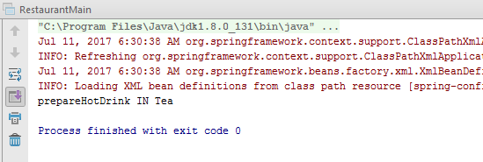

* **Get both the beans and invoke prepareHotDrink method via hotDrink**

**instance variables. Try inner bean with expressTeaRestaurant.**

**Restraunt.java**

**package** main.resource;  
  
**import** org.springframework.beans.factory.annotation.Autowired;  
**import** org.springframework.beans.factory.annotation.Required;  
**public class** Restaurant {  
 HotDrink **hotDrink**;  
  
**public** HotDrink getHotDrink() {  
 **return hotDrink**;  
 }  
  
**public void** setHotDrink(HotDrink hotDrink) {  
 **this**.**hotDrink** = hotDrink;  
 }  
  
 @Override  
 **public** String toString() {  
**return "HotDrink: "**+**hotDrink**;  
 }  
}

**HotDrink.java**

**package** main.resource;  
  
**public interface** HotDrink {  
 **public void** prepareHotDrink();  
  
  
}

**ExpressTea.java**

**package** main.resource;  
**public class** ExpressTea **implements** HotDrink{  
 **public void** prepareHotDrink(){  
 System.***out***.println(**"Prepare hot drink inside ExpressTea"**);  
 }  
  
}

**spring-config.java**

*<?***xml version="1.0" encoding="UTF-8"***?>*<**beans xmlns="http://www.springframework.org/schema/beans"  
 xmlns:xsi="http://www.w3.org/2001/XMLSchema-instance"  
 xsi:schemaLocation="http://www.springframework.org/schema/beans http://www.springframework.org/schema/beans/spring-beans.xsd"**><**bean name="tea" class="main.resource.Tea"**></**bean**>  
 <**bean name="expresstea" class="main.resource.ExpressTea"**></**bean**>  
 <**bean name="tearestaurant" class="main.resource.Restaurant"**>  
 <**property name="hotDrink" ref="tea"**></**property**>  
 </**bean**>  
  
 <**bean name="restaurant" class="main.resource.Restaurant"**>  
 <**property name="hotDrink"**>  
 <**bean name = "expressTeaRestaurant" class="main.resource.ExpressTea"**></**bean**>  
 </**property**>  
 </**bean**>  
  
</**beans**>

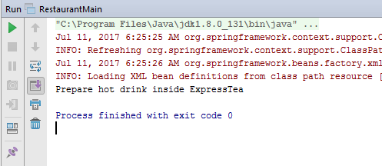

* **Create Class Complex as follows: class complex {    List list;**

**Set set;**

**Map map;**

**} Initialize all the instance variables of the complex class using Spring XML. Give bean name as**

**complexBean. Get the bean and display the properties.**

**Complex.java**

**package** main.resource;  
  
**import** java.util.List;  
**import** java.util.Map;  
**import** java.util.Set;  
  
**public class** Complex {  
 List **list**;  
 Set **set**;  
 Map **map**;  
  
 **public** List getList() {  
 **return list**;  
 }  
  
 **public void** setList(List list) {  
 **this**.**list** = list;  
 }  
  
 **public** Set getSet() {  
 **return set**;  
 }  
  
 **public void** setSet(Set set) {  
 **this**.**set** = set;  
 }  
  
 **public** Map getMap() {  
 **return map**;  
 }  
  
 **public void** setMap(Map map) {  
 **this**.**map** = map;  
 }  
  
 @Override  
 **public** String toString() {  
**return "List: "**+**list**+**"\nSet: "**+**set**+**"\nMap: "**+**map**;  
 }  
}

**ComplexMain.java**

**package** main.resource;  
  
**import** org.springframework.context.ApplicationContext;  
**import** org.springframework.context.support.ClassPathXmlApplicationContext;  
  
**public class** ComplexMain {  
 **public static void** main(String[] args) {  
 ApplicationContext applicationContext = **new** ClassPathXmlApplicationContext(**"spring-config.xml"**);  
 Complex complex = (Complex) applicationContext.getBean(**"complexbean"**);  
 System.***out***.println(complex);  
  
 }  
}

**spring-config.xml**

*<?***xml version="1.0" encoding="UTF-8"***?>*<**beans xmlns="http://www.springframework.org/schema/beans"  
 xmlns:xsi="http://www.w3.org/2001/XMLSchema-instance"  
 xsi:schemaLocation="http://www.springframework.org/schema/beans http://www.springframework.org/schema/beans/spring-beans.xsd"**><**bean name="complexbean" class="main.resource.Complex"**>  
 <**property name="list"**>  
 <**list**>  
 <**value**>10</**value**>  
 <**value**>20</**value**>  
 <**value**>30</**value**>  
 <**value**>40</**value**>  
 </**list**>  
 </**property**>  
 <**property name="set"**>  
 <**set**>  
 <**value**>10</**value**>  
 <**value**>10</**value**>  
 <**value**>20</**value**>  
 <**value**>30</**value**>  
 </**set**>  
 </**property**>  
 <**property name="map"**>  
 <**map**>  
 <**entry key="1" value="10"**></**entry**>  
 <**entry key="2" value="20"**></**entry**>  
 <**entry key="3" value="30"**></**entry**>  
 <**entry key="4" value="40"**></**entry**>  
 </**map**>  
 </**property**>  
 </**bean**>  
  
  
  
 </**beans**>

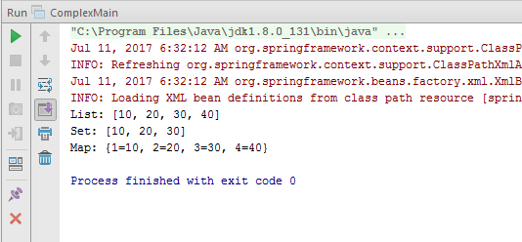

* **Autowire hotDrink in Restaurant with tea bean byName, byType and constructor.**

**Autowire by Name**

**Restraunt.java**

**package** main.resource;  
  
**import** org.springframework.beans.factory.annotation.Autowired;  
**import** org.springframework.beans.factory.annotation.Required;  
**public class** Restaurant {  
 HotDrink **hotDrink**;  
**public** HotDrink getHotDrink() {  
 **return hotDrink**;  
 }  
  
**public void** setHotDrink(HotDrink hotDrink) {  
 **this**.**hotDrink** = hotDrink;  
 }  
  
 @Override  
 **public** String toString() {  
**return "HotDrink: "**+**hotDrink**;  
 }  
}

**RestrauntMain.java**

**package** main.resource;  
  
**import** org.springframework.context.ApplicationContext;  
**import** org.springframework.context.support.ClassPathXmlApplicationContext;  
  
*/**  
 * Created by krishan on 6/30/2017.  
 */***public class** RestaurantMain {  
 **public static void** main(String[] args) {  
 ApplicationContext applicationContext = **new** ClassPathXmlApplicationContext(**"spring-config.xml"**);  
 Restaurant restaurant2 = (Restaurant) applicationContext.getBean(**"restaurant2"**);  
 System.***out***.println(**"Auto wiring by Name"**);  
 restaurant2.**hotDrink**.prepareHotDrink();  
  
}  
}

**spring-config.xml**

*<?***xml version="1.0" encoding="UTF-8"***?>*<**beans xmlns="http://www.springframework.org/schema/beans"  
 xmlns:xsi="http://www.w3.org/2001/XMLSchema-instance"  
 xsi:schemaLocation="http://www.springframework.org/schema/beans http://www.springframework.org/schema/beans/spring-beans.xsd"**>  
<**bean name="tea" class="main.resource.Tea"**></**bean**>  
 <**bean name="expresstea" class="main.resource.ExpressTea"**></**bean**>  
 <**bean name="tearestaurant" class="main.resource.Restaurant"**>  
 <**property name="hotDrink" ref="tea"**></**property**>  
 </**bean**>  
  
 <**bean name="restaurant" class="main.resource.Restaurant"**>  
 <**property name="hotDrink"**>  
 <**bean name = "expressTeaRestaurant" class="main.resource.ExpressTea"**></**bean**>  
 </**property**>  
 </**bean**>  
  
<**bean name="restaurant2" class="main.resource.Restaurant" autowire="byName"**>  
 </**bean**>  
<**bean name="hotDrink" class="main.resource.Tea"**></**bean**>  
 </**beans**>

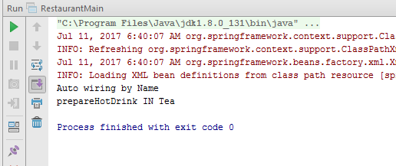

**Autowiring by type**

**RestrauntMain.java**

**package** main.resource;  
  
**import** org.springframework.context.ApplicationContext;  
**import** org.springframework.context.support.ClassPathXmlApplicationContext;  
  
**public class** RestaurantMain {  
 **public static void** main(String[] args) {  
 ApplicationContext applicationContext = **new** ClassPathXmlApplicationContext(**"spring-config.xml"**);  
 Restaurant restaurant3 = (Restaurant) applicationContext.getBean(**"restaurant3"**);  
 System.***out***.println(**"Auto wiring By Type"**);  
 restaurant3.**hotDrink**.prepareHotDrink();  
  
 }  
}

**spring-config.xml**

*<?***xml version="1.0" encoding="UTF-8"***?>*<**beans xmlns="http://www.springframework.org/schema/beans"  
 xmlns:xsi="http://www.w3.org/2001/XMLSchema-instance"  
 xsi:schemaLocation="http://www.springframework.org/schema/beans http://www.springframework.org/schema/beans/spring-beans.xsd"**>  
  
 <**bean name="expresstea" class="main.resource.ExpressTea"**></**bean**>  
<**bean name="restaurant3" class="main.resource.Restaurant" autowire="byType"**>  
 </**bean**>  
  
 </**beans**>

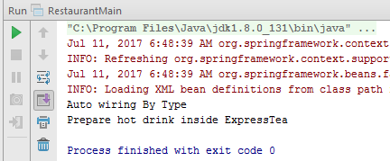

**Autowiring by constructor**

**RestrauntMain.java**

**package** main.resource;  
  
**import** org.springframework.context.ApplicationContext;  
**import** org.springframework.context.support.ClassPathXmlApplicationContext;  
  
*/**  
 * Created by krishan on 6/30/2017.  
 */***public class** RestaurantMain {  
 **public static void** main(String[] args) {  
 ApplicationContext applicationContext = **new** ClassPathXmlApplicationContext(**"spring-config.xml"**);  
 Restaurant restaurant4 = (Restaurant) applicationContext.getBean(**"restaurant4"**);  
 System.***out***.println(**"Auto wiring By Constructor"**);  
 restaurant4.**hotDrink**.prepareHotDrink();  
  
 }  
}

**spring-config.xml**

*<?***xml version="1.0" encoding="UTF-8"***?>*<**beans xmlns="http://www.springframework.org/schema/beans"  
 xmlns:xsi="http://www.w3.org/2001/XMLSchema-instance"  
 xsi:schemaLocation="http://www.springframework.org/schema/beans http://www.springframework.org/schema/beans/spring-beans.xsd"**>  
<**bean name="expresstea" class="main.resource.ExpressTea"**></**bean**>  
<**bean name="restaurant4" class="main.resource.Restaurant" autowire="constructor"**>  
  
 </**bean**>  
  
</**beans**>

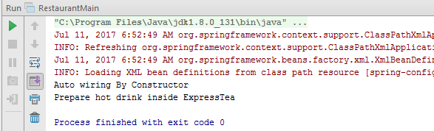

* **Set the scope of the teaRestaurant bean as proptotype and check the scope type after accessing the bean.**

**Spring-config.xml**

*<?***xml version="1.0" encoding="UTF-8"***?>*<**beans xmlns="http://www.springframework.org/schema/beans"  
 xmlns:xsi="http://www.w3.org/2001/XMLSchema-instance"  
 xsi:schemaLocation="http://www.springframework.org/schema/beans http://www.springframework.org/schema/beans/spring-beans.xsd"**>  
<**bean name="tea" class="main.resource.Tea"** ></**bean**>  
<**bean name="tearestaurant" class="main.resource.Restaurant" scope="prototype"**>  
 <**property name="hotDrink" ref="tea"** ></**property**>  
 </**bean**>  
</**beans**>

**Restaurant.java**

**package** main.resource;  
  
**import** org.springframework.beans.factory.annotation.Autowired;  
**import** org.springframework.beans.factory.annotation.Required;  
  
**public class** Restaurant {  
 HotDrink **hotDrink**;  
**public** HotDrink getHotDrink() {  
 **return hotDrink**;  
 }  
  
@Required  
 **public void** setHotDrink(HotDrink hotDrink) {  
 **this**.**hotDrink** = hotDrink;  
 }  
  
 @Override  
 **public** String toString() {  
 System.***out***.println(**super**.toString());  
 **return "HotDrink: "**+**hotDrink**;  
 }  
}

**RestaurantMain.java**

**package** main.resource;  
  
**import** org.springframework.context.ApplicationContext;  
**import** org.springframework.context.support.ClassPathXmlApplicationContext;  
**public class** RestaurantMain {  
 **public static void** main(String[] args) {  
 ApplicationContext applicationContext = **new** ClassPathXmlApplicationContext(**"spring-config.xml"**);  
 Restaurant restaurant = (Restaurant) applicationContext.getBean(**"tearestaurant"**);  
 restaurant.**hotDrink**.prepareHotDrink();  
 System.***out***.println(**"Is TeaRestaurant is Prototype: "**+applicationContext.isPrototype(**"tearestaurant"**));  
  
 }  
}

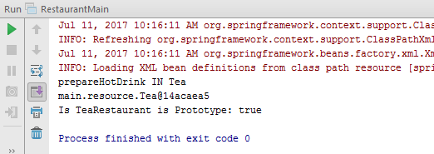

* **Use @Required annotation for hotDrink setter method in Restaurant class.**

**Spring-config.xml**

*<?***xml version="1.0" encoding="UTF-8"***?>*<**beans xmlns="http://www.springframework.org/schema/beans"  
 xmlns:xsi="http://www.w3.org/2001/XMLSchema-instance"  
 xsi:schemaLocation="http://www.springframework.org/schema/beans http://www.springframework.org/schema/beans/spring-beans.xsd"**>  
<**bean name="hotDrink" class="main.resource.Tea"**></**bean**>  
 <**bean name="required" class="main.resource.Restaurant"**>  
 <**property name="hotDrink" ref="hotDrink"**></**property**>  
 </**bean**>  
  
</**beans**>

**Restaurant.java**

**package** main.resource;  
  
**import** org.springframework.beans.factory.annotation.Autowired;  
**import** org.springframework.beans.factory.annotation.Required;  
  
**public class** Restaurant {  
 HotDrink **hotDrink**;  
  
**public** HotDrink getHotDrink() {  
 **return hotDrink**;  
 }  
  
@Required  
 **public void** setHotDrink(HotDrink hotDrink) {  
 **this**.**hotDrink** = hotDrink;  
 }  
  
 @Override  
 **public** String toString() {  
 System.***out***.println(**super**.toString());  
 **return "HotDrink: "**+**hotDrink**;  
 }  
}

**RestaurantMain.java**

**package** main.resource;  
  
**import** org.springframework.context.ApplicationContext;  
**import** org.springframework.context.support.ClassPathXmlApplicationContext;  
**public class** RestaurantMain {  
 **public static void** main(String[] args) {  
 ApplicationContext applicationContext = **new** ClassPathXmlApplicationContext(**"spring-config.xml"**);  
 Restaurant restaurant4 = (Restaurant) applicationContext.getBean(**"required"**);  
 restaurant4.**hotDrink**.prepareHotDrink();  
 }  
}

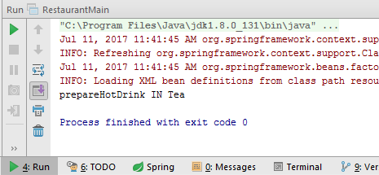

* **Use @Autowired annotation to wire Tea with Restaurant class Using setter method, field and constructor.**

**Using setter method**

**Spring-config.xml**

*<?***xml version="1.0" encoding="UTF-8"***?>*<**beans xmlns="http://www.springframework.org/schema/beans"  
 xmlns:xsi="http://www.w3.org/2001/XMLSchema-instance"  
 xsi:schemaLocation="http://www.springframework.org/schema/beans http://www.springframework.org/schema/beans/spring-beans.xsd"**><**bean name="tea" class="main.resource.Tea"** ></**bean**>  
<**bean name="restaurant" class="main.resource.Restaurant"**>  
 <**property name="hotDrink" ref="tea"**></**property**>  
 </**bean**>  
  
  
</**beans**>

**Restaurant.java**

**package** main.resource;  
  
 **import** org.springframework.beans.factory.annotation.Autowired;  
 **import** org.springframework.beans.factory.annotation.Required;  
  
  
 **public class** Restaurant {  
 HotDrink **hotDrink**;  
**public** HotDrink getHotDrink() {  
 **return hotDrink**;  
 }  
@Autowired  
 **public void** setHotDrink(HotDrink hotDrink) {  
 **this**.**hotDrink** = hotDrink;  
 }  
  
 @Override  
 **public** String toString() {  
 System.***out***.println(**super**.toString());  
 **return "HotDrink: "**+**hotDrink**;  
 }  
 }

**RestaurantMain.java**

**package** main.resource;  
  
**import** org.springframework.context.ApplicationContext;  
**import** org.springframework.context.support.ClassPathXmlApplicationContext;  
  
*/**  
 * Created by krishan on 6/30/2017.  
 */***public class** RestaurantMain {  
 **public static void** main(String[] args) {  
 ApplicationContext applicationContext = **new** ClassPathXmlApplicationContext(**"spring-config.xml"**);  
Restaurant restaurant1 = (Restaurant) applicationContext.getBean(**"restaurant"**);  
 restaurant1.**hotDrink**.prepareHotDrink();  
  
 }  
}

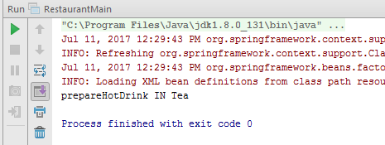

**Using field**

**Spring-config.xml**

*<?***xml version="1.0" encoding="UTF-8"***?>*<**beans xmlns="http://www.springframework.org/schema/beans"  
 xmlns:xsi="http://www.w3.org/2001/XMLSchema-instance"  
 xsi:schemaLocation="http://www.springframework.org/schema/beans http://www.springframework.org/schema/beans/spring-beans.xsd"**><**bean name="tea" class="main.resource.Tea"** ></**bean**>  
<**bean name="restaurant" class="main.resource.Restaurant"**>  
 <**property name="hotDrink" ref="tea"**></**property**>  
 </**bean**>  
  
  
</**beans**>

**Restaurant.java**

**package** main.resource;  
  
 **import** org.springframework.beans.factory.annotation.Autowired;  
 **import** org.springframework.beans.factory.annotation.Required;  
  
  
 **public class** Restaurant {  
 @Autowired  
 HotDrink **hotDrink**;  
  
**public** HotDrink getHotDrink() {  
 **return hotDrink**;  
 }  
  
**public void** setHotDrink(HotDrink hotDrink) {  
 **this**.**hotDrink** = hotDrink;  
 }  
  
 @Override  
 **public** String toString() {  
 System.***out***.println(**super**.toString());  
 **return "HotDrink: "**+**hotDrink**;  
 }  
 }

**RestaurantMain.java**

**package** main.resource;  
  
**import** org.springframework.context.ApplicationContext;  
**import** org.springframework.context.support.ClassPathXmlApplicationContext;  
  
*/**  
 * Created by krishan on 6/30/2017.  
 */***public class** RestaurantMain {  
 **public static void** main(String[] args) {  
 ApplicationContext applicationContext = **new** ClassPathXmlApplicationContext(**"spring-config.xml"**);Restaurant restaurant1 = (Restaurant) applicationContext.getBean(**"restaurant"**);  
 restaurant1.**hotDrink**.prepareHotDrink();  
  
 }  
}

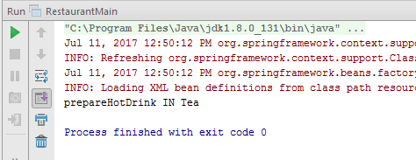

**Using Constructor**

**Spring-config.xml**

*<?***xml version="1.0" encoding="UTF-8"***?>*<**beans xmlns="http://www.springframework.org/schema/beans"  
 xmlns:xsi="http://www.w3.org/2001/XMLSchema-instance"  
 xsi:schemaLocation="http://www.springframework.org/schema/beans http://www.springframework.org/schema/beans/spring-beans.xsd"**>  
<**bean name="tea" class="main.resource.Tea"** ></**bean**>  
 <**bean name="restaurant" class="main.resource.Restaurant"**>  
 <**constructor-arg ref="tea"**></**constructor-arg**>  
 </**bean**>  
  
  
</**beans**>

**Restaurant.java**

**package** main.resource;  
  
 **import** org.springframework.beans.factory.annotation.Autowired;  
 **import** org.springframework.beans.factory.annotation.Required;  
  
  
 **public class** Restaurant {  
HotDrink **hotDrink**;  
  
 @Autowired  
 **public** Restaurant(HotDrink hotDrink) {  
 **this**.**hotDrink** = hotDrink;  
 }  
 **public** HotDrink getHotDrink() {  
 **return hotDrink**;  
 }  
  
**public void** setHotDrink(HotDrink hotDrink) {  
 **this**.**hotDrink** = hotDrink;  
 }  
  
 @Override  
 **public** String toString() {  
 System.***out***.println(**super**.toString());  
 **return "HotDrink: "**+**hotDrink**;  
 }  
 }

**RestaurantMain.java**

**package** main.resource;  
  
**import** org.springframework.context.ApplicationContext;  
**import** org.springframework.context.support.ClassPathXmlApplicationContext;  
  
*/**  
 * Created by krishan on 6/30/2017.  
 */***public class** RestaurantMain {  
 **public static void** main(String[] args) {  
 ApplicationContext applicationContext = **new** ClassPathXmlApplicationContext(**"spring-config.xml"**);  
Restaurant restaurant1 = (Restaurant) applicationContext.getBean(**"restaurant"**);  
 restaurant1.**hotDrink**.prepareHotDrink();  
}  
}

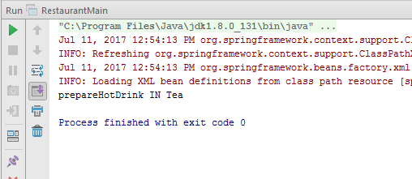

* **Use @Component, @Controller, @Repository etc annotation to configure Tea and Restaurant in Spring Container.**

**Using Controller**

**Spring-config.xml**

*<?***xml version="1.0" encoding="UTF-8"***?>*<**beans xmlns="http://www.springframework.org/schema/beans"  
 xmlns:context="http://www.springframework.org/schema/context"  
 xmlns:xsi="http://www.w3.org/2001/XMLSchema-instance"  
 xsi:schemaLocation="http://www.springframework.org/schema/beans  
 http://www.springframework.org/schema/beans/spring-beans.xsd  
 http://www.springframework.org/schema/context  
 http://www.springframework.org/schema/context/spring-context.xsd"**>  
  
 <**context:component-scan base-package="main.resource"**></**context:component-scan**>  
 <**bean name="hotDrink" class="main.resource.Tea"**></**bean**>  
</**beans**>

**Restaurant.java**

**package** main.resource;  
  
 **import** org.springframework.beans.factory.annotation.Autowired;  
 **import** org.springframework.beans.factory.annotation.Required;  
 **import** org.springframework.stereotype.Controller;  
  
 @Controller  
 **public class** Restaurant {  
HotDrink **hotDrink**;  
  
 @Autowired  
 **public** Restaurant(HotDrink hotDrink) {  
 **this**.**hotDrink** = hotDrink;  
 }  
 **public** HotDrink getHotDrink() {  
 **return hotDrink**;  
 }  
  
**public void** setHotDrink(HotDrink hotDrink) {  
 **this**.**hotDrink** = hotDrink;  
 }  
  
 @Override  
 **public** String toString() {  
 System.***out***.println(**super**.toString());  
 **return "HotDrink: "**+**hotDrink**;  
 }  
 }

**HotDrink.java**

**package** main.resource;  
  
**import** org.springframework.stereotype.Controller;  
**public interface** HotDrink {  
 **public void** prepareHotDrink();  
  
  
}

**Tea.java**

**package** main.resource;  
  
**import** org.springframework.stereotype.Controller;  
  
@Controller  
**public class** Tea **implements** HotDrink{  
 **public void** prepareHotDrink(){  
 System.***out***.println(**"prepareHotDrink IN Tea"**);  
}  
  
 @Override  
 **public** String toString() {  
 **return super**.toString();  
 }  
}

**ExpressTea.java**

**package** main.resource;  
  
**import** org.springframework.stereotype.Controller;  
@Controller  
**public class** ExpressTea **implements** HotDrink{  
 **public void** prepareHotDrink(){  
 System.***out***.println(**"Prepare hot drink inside ExpressTea"**);  
 }  
  
}

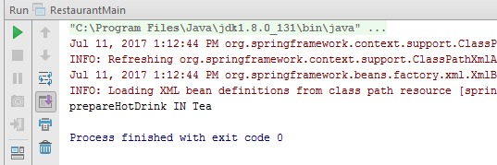

**Using Component**

**Spring-config.xml**

*<?***xml version="1.0" encoding="UTF-8"***?>*<**beans xmlns="http://www.springframework.org/schema/beans"  
 xmlns:context="http://www.springframework.org/schema/context"  
 xmlns:xsi="http://www.w3.org/2001/XMLSchema-instance"  
 xsi:schemaLocation="http://www.springframework.org/schema/beans  
 http://www.springframework.org/schema/beans/spring-beans.xsd  
 http://www.springframework.org/schema/context  
 http://www.springframework.org/schema/context/spring-context.xsd"**>  
  
 <**context:component-scan base-package="main.resource"**></**context:component-scan**>  
 <**bean name="hotDrink" class="main.resource.Tea"**></**bean**>  
 </**beans**>

**Restaurant.java**

**package** main.resource;  
  
 **import** org.springframework.beans.factory.annotation.Autowired;  
 **import** org.springframework.beans.factory.annotation.Required;  
 **import** org.springframework.stereotype.Component;  
 **import** org.springframework.stereotype.Controller;  
@Component  
 **public class** Restaurant {  
HotDrink **hotDrink**;  
  
 @Autowired  
 **public** Restaurant(HotDrink hotDrink) {  
 **this**.**hotDrink** = hotDrink;  
 }  
 **public** HotDrink getHotDrink() {  
 **return hotDrink**;  
 }  
**public void** setHotDrink(HotDrink hotDrink) {  
 **this**.**hotDrink** = hotDrink;  
 }  
  
 @Override  
 **public** String toString() {  
 System.***out***.println(**super**.toString());  
 **return "HotDrink: "**+**hotDrink**;  
 }  
 }

**RestaurantMain.java**

**package** main.resource;  
  
**import** org.springframework.context.ApplicationContext;  
**import** org.springframework.context.support.ClassPathXmlApplicationContext;  
  
**public class** RestaurantMain {  
 **public static void** main(String[] args) {  
 ApplicationContext applicationContext = **new** ClassPathXmlApplicationContext(**"spring-config.xml"**);  
 Restaurant restaurant1 = (Restaurant) applicationContext.getBean(Restaurant.**class**);  
 restaurant1.**hotDrink**.prepareHotDrink();  
  
}  
}

**HotDrink.java**

**package** main.resource;  
  
**import** org.springframework.stereotype.Controller;  
  
**public interface** HotDrink {  
 **public void** prepareHotDrink();  
  
  
}

**Tea.java**

**package** main.resource;  
  
**import** org.springframework.stereotype.Component;  
**import** org.springframework.stereotype.Controller;  
  
@Component  
**public class** Tea **implements** HotDrink{  
 **public void** prepareHotDrink(){  
 System.***out***.println(**"prepareHotDrink IN Tea"**);  
}  
  
 @Override  
 **public** String toString() {  
 **return super**.toString();  
 }  
}

**ExpressTea.java**

**package** main.resource;  
  
**import** org.springframework.stereotype.Component;  
**import** org.springframework.stereotype.Controller;  
  
@Component  
**public class** ExpressTea **implements** HotDrink{  
 **public void** prepareHotDrink(){  
 System.***out***.println(**"Prepare hot drink inside ExpressTea"**);  
 }  
  
}



**Using Repository**

**Spring-config.xml**

*<?***xml version="1.0" encoding="UTF-8"***?>*<**beans xmlns="http://www.springframework.org/schema/beans"  
 xmlns:context="http://www.springframework.org/schema/context"  
 xmlns:xsi="http://www.w3.org/2001/XMLSchema-instance"  
 xsi:schemaLocation="http://www.springframework.org/schema/beans  
 http://www.springframework.org/schema/beans/spring-beans.xsd  
 http://www.springframework.org/schema/context  
 http://www.springframework.org/schema/context/spring-context.xsd"**>  
  
 <**context:component-scan base-package="main.resource"**></**context:component-scan**>  
<**bean name="hotDrink" class="main.resource.Tea"**></**bean**>  
</**beans**>

**Restaurant.java**

**package** main.resource;  
  
 **import** org.springframework.beans.factory.annotation.Autowired;  
 **import** org.springframework.beans.factory.annotation.Required;  
 **import** org.springframework.stereotype.Component;  
 **import** org.springframework.stereotype.Controller;  
  
@Component  
 **public class** Restaurant {  
HotDrink **hotDrink**;  
  
 @Autowired  
 **public** Restaurant(HotDrink hotDrink) {  
 **this**.**hotDrink** = hotDrink;  
 }  
 **public** HotDrink getHotDrink() {  
 **return hotDrink**;  
 }  
  
**public void** setHotDrink(HotDrink hotDrink) {  
 **this**.**hotDrink** = hotDrink;  
 }  
  
 @Override  
 **public** String toString() {  
 System.***out***.println(**super**.toString());  
 **return "HotDrink: "**+**hotDrink**;  
 }  
 }

**RestaurantMain.java**

**package** main.resource;  
  
**import** org.springframework.context.ApplicationContext;  
**import** org.springframework.context.support.ClassPathXmlApplicationContext;  
**public class** RestaurantMain {  
 **public static void** main(String[] args) {  
 ApplicationContext applicationContext = **new** ClassPathXmlApplicationContext(**"spring-config.xml"**);  
Restaurant restaurant1 = (Restaurant) applicationContext.getBean(Restaurant.**class**);  
 restaurant1.**hotDrink**.prepareHotDrink();  
  
 }  
}

**HotDrink.java**

**package** main.resource;  
  
**import** org.springframework.stereotype.Controller;  
**public interface** HotDrink {  
 **public void** prepareHotDrink();  
  
  
}

**Tea.java**

**package** main.resource;  
  
**import** org.springframework.stereotype.Component;  
**import** org.springframework.stereotype.Controller;  
**import** org.springframework.stereotype.Repository;  
  
@Repository  
**public class** Tea **implements** HotDrink{  
 **public void** prepareHotDrink(){  
 System.***out***.println(**"prepareHotDrink IN Tea"**);  
}  
  
 @Override  
 **public** String toString() {  
 **return super**.toString();  
 }  
}

**ExpressTea.java**

**package** main.resource;  
  
**import** org.springframework.stereotype.Component;  
**import** org.springframework.stereotype.Controller;  
**import** org.springframework.stereotype.Repository;  
  
@Repository  
**public class** ExpressTea **implements** HotDrink{  
 **public void** prepareHotDrink(){  
 System.***out***.println(**"Prepare hot drink inside ExpressTea"**);  
 }  
  
}

